Name: Kamble Kajal Rajendra

Roll No: 514

Assign No : 07 Web Service

=========================================================================

package org.me.calculator;

import javax.jws.WebService;

import javax.jws.WebMethod;

import javax.jws.WebParam;

import javax.ejb.Stateless;

/**

*

* @author hp

*/

@WebService(serviceName = "CalculatorWS")

@Stateless()

public class CalculatorWS {

/**

* Web service operation

*/

@WebMethod(operationName = "mul")

public int mul(@WebParam(name = "num1") int num1, @WebParam(name = "num2") int num2) {

//TODO write your implementation code here:

int result=num1*num2;

return result;

}

}

/*

* To change this license header, choose License Headers in Project Properties.

* To change this template file, choose Tools | Templates

* and open the template in the editor.

*/

package calculatorws_client_application;

/**

*

* @author hp

*/

public class CalculatorWS_Client_Application {

/**

* @param args the command line arguments

*/

public static void main(String[] args) {

// TODO code application logic here

try{

int num1=14;

int num2=10;

int result=mul(num1, num2);

System.out.println("Result: " + result);

}

catch(Exception e){

System.out.println("Exception: " + e);

}

}

private static int mul(int num1, int num2) {

org.me.calculator.CalculatorWS_Service service = new org.me.calculator.CalculatorWS_Service();

org.me.calculator.CalculatorWS port = service.getCalculatorWSPort();

return port.mul(num1, num2);

}

}

O/P:

ant -f C:\\Users\\hp\\Documents\\NetBeansProjects\\CalculatorWS_Client_Application -Dnb.internal.action.name=run run

init:

Deleting: C:\Users\hp\Documents\NetBeansProjects\CalculatorWS_Client_Application\build\built-jar.properties

deps-jar:

Updating property file: C:\Users\hp\Documents\NetBeansProjects\CalculatorWS_Client_Application\build\built-jar.properties

wsimport-init:

wsimport-client-CalculatorWS:

files are up to date

wsimport-client-generate:

compile:

run:

Result: 140

BUILD SUCCESSFUL (total time: 0 seconds)

/*

* To change this license header, choose License Headers in Project Properties.

* To change this template file, choose Tools | Templates

* and open the template in the editor.

*/

package org.me.calculator.client;

import java.io.IOException;

import java.io.PrintWriter;

import javax.servlet.ServletException;

import javax.servlet.annotation.WebServlet;

import javax.servlet.http.HttpServlet;

import javax.servlet.http.HttpServletRequest;

import javax.servlet.http.HttpServletResponse;

/**

*

* @author hp

*/

@WebServlet(name = "ClientServlet", urlPatterns = {"/ClientServlet"})

public class ClientServlet extends HttpServlet {

/**

* Processes requests for both HTTP <code>GET</code> and <code>POST</code>

* methods.

*

* @param request servlet request

* @param response servlet response

* @throws ServletException if a servlet-specific error occurs

* @throws IOException if an I/O error occurs

*/

protected void processRequest(HttpServletRequest request, HttpServletResponse response)

throws ServletException, IOException {

response.setContentType("text/html;charset=UTF-8");

try (PrintWriter out = response.getWriter()) {

/* TODO output your page here. You may use following sample code. */

out.println("<!DOCTYPE html>");

out.println("<html>");

out.println("<head>");

out.println("<title>Servlet ClientServlet</title>");

out.println("</head>");

out.println("<body>");

out.println("<h1>Servlet ClientServlet at " + request.getContextPath() + "</h1>");

try{

int num1=14;

int num2=10;

int result=num1*num2;

out.println("Result is: "+result);

}

catch (Exception e) {

out.println("Exception: " + e);

}

out.println("</body>");

out.println("</html>");

}

}

// <editor-fold defaultstate="collapsed" desc="HttpServlet methods. Click on the + sign on the left to edit the code.">

/**

* Handles the HTTP <code>GET</code> method.

*

* @param request servlet request

* @param response servlet response

* @throws ServletException if a servlet-specific error occurs

* @throws IOException if an I/O error occurs

*/

@Override

protected void doGet(HttpServletRequest request, HttpServletResponse response)

throws ServletException, IOException {

processRequest(request, response);

}

/**

* Handles the HTTP <code>POST</code> method.

*

* @param request servlet request

* @param response servlet response

* @throws ServletException if a servlet-specific error occurs

* @throws IOException if an I/O error occurs

*/

@Override

protected void doPost(HttpServletRequest request, HttpServletResponse response)

throws ServletException, IOException {

processRequest(request, response);

}

/**

* Returns a short description of the servlet.

*

* @return a String containing servlet description

*/

@Override

public String getServletInfo() {

return "Short description";

}// </editor-fold>

}

O/P:

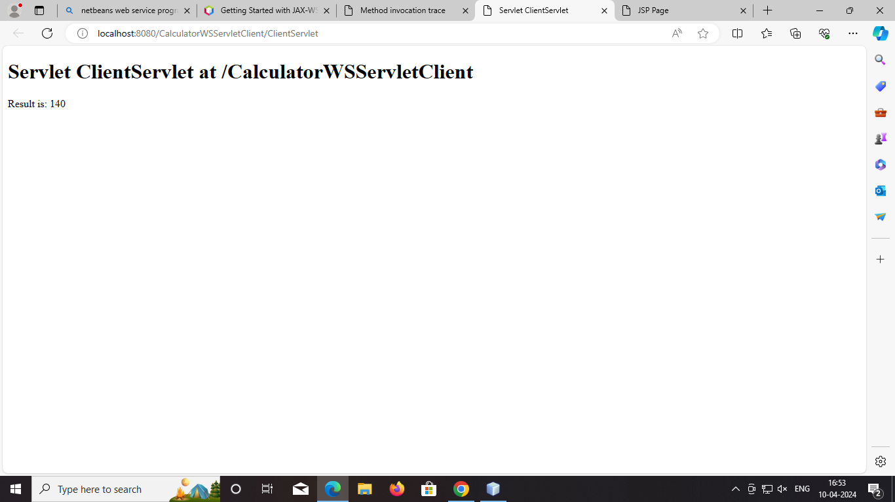

<%--

Document : index

Created on : 10 Apr, 2024, 4:49:27 PM

Author : hp

--%>

<%@page contentType="text/html" pageEncoding="UTF-8"%>

<!DOCTYPE html>

<html>

<head>

<meta http-equiv="Content-Type" content="text/html; charset=UTF-8">

<title>JSP Page</title>

</head>

<body>

<h1>Hello World!</h1> <%-- start web service invocation --%><hr/>

<%

try {

org.me.calculator.CalculatorWS_Service service = new org.me.calculator.CalculatorWS_Service();

org.me.calculator.CalculatorWS port = service.getCalculatorWSPort();

// TODO initialize WS operation arguments here

int num1 = 14;

int num2 = 10;

// TODO process result here

int result = port.mul(num1, num2);

out.println("Result = "+result);

} catch (Exception ex) {

// TODO handle custom exceptions here

}

%>

<%-- end web service invocation --%><hr/>

</body>

</html>

O/P:

